SIMATS ENGINEERING

Department of Computer Science and Engineering COMMON ASSIGNMENT REPORT
Library Book Reservation System using Zoho Creator (SaaS) with Big Data Analytics

Course Code: CSA15 Course: Cloud Computing and Big Data Analytics

Submitted by

Student | Register Number
R. Deepasri | 192511309
M. Parinitha Lakshmi Sandhoshi | 192525064
Assignment scope: cloud/SaaS application design, Zoho Creator implementation evidence, library reservation workflow, big-data problem analysis, sample transaction dataset, and MapReduce-based reservation-frequency analytics.

CERTIFICATE AND DECLARATION
This report is submitted as the common assignment work for CSA15 – Cloud Computing and Big Data Analytics. The assignment follows the prescribed requirement that teams independently design, develop, implement, test, analyze and document their solution, with evidence of implementation and learning outcomes.

Team Members
Name | Register Number | Role in the Assignment
R. Deepasri | 192511309 | Zoho Creator implementation, reports, analytics integration,  documentation
M. Parinitha | 192525064 | Data model, testing, workflow analysis, dataset and report support

Declaration
We declare that this report represents our assignment work and that external sources, tools and course-provided material have been acknowledged. The report distinguishes the demonstrated Zoho Creator screens from the sample analytics dataset prepared for MapReduce experimentation.

Student Signature | Date
R. Deepasri
M. Parinitha

Source basis: The common-assignment instructions require a complete report covering problem formulation, objectives, requirements, relevant course concepts, design, algorithm/flowchart, implementation/tools, test cases, screenshots, results, analysis, SDG relevance, conclusion, contributions, references and individual reflection.

ACKNOWLEDGEMENT
We express our sincere gratitude to the Department of Computer Science and Engineering, SIMATS Engineering, for providing the common-assignment framework through which cloud computing and big-data concepts could be applied to a realistic library scenario.
We thank our course faculty for the guidance provided on Software as a Service, cloud access, virtualization concepts, big-data characteristics and MapReduce processing. The assignment encouraged us to move beyond a theoretical description and produce a working cloud application with forms, reports and sample records.
We also acknowledge Zoho Creator as the platform used to construct the cloud-based application interface and data-entry/reporting components. The screenshots included in this report document the application state available during development. The supporting screenshot evidence is retained in the accompanying screenshots PDF.
Finally, we thank our teammates and peers for discussions around database fields, reservation rules, testing scenarios and analytics design. The project helped us understand how a small information system can be extended into a cloud-accessible application and subsequently treated as a source of transaction data for big-data analysis.

Key learning areas
- Mapping a real-world library process into structured cloud forms and reports.
- Understanding why SaaS reduces the need for local infrastructure management.
- Designing validations and status transitions for reservations and book availability.
- Preparing a transaction dataset suitable for frequency analysis.
- Using mapper/reducer logic to convert reservation records into aggregated demand information.

The final report is organized to match the assignment question, assessment expectations and supplied report-subtopic structure while adapting the example domain from property management to library book reservation.

ABSTRACT
The Library Book Reservation System is a cloud-based Software as a Service application designed using Zoho Creator. The system addresses the need for a centralized way to maintain book records, identify availability, record reservations and support librarian operations. The assignment question requires students and faculty members to be able to register, search for books, check availability, reserve or cancel books, join a waiting list and view reservation status, while librarians manage book records, issue/return activities, due dates, fines, approvals and reports.
The implementation uses a form-driven data model containing book, member, reservation and issue/return information. The supplied Zoho Creator evidence demonstrates the Book Form, Book Form Report, Library Report, Available Book view and dashboard navigation. Sorting and report views provide a simple operational interface for examining stored records.
For the big-data component, a sample library-transaction dataset is prepared with transaction ID, member ID, book ID, title, category, date and status. The dataset is used to illustrate volume, velocity, variety, veracity/data quality, privacy and scalability concerns. A MapReduce-style mapper emits (Book_ID, 1) for each reservation and the reducer sums values for each key, producing reservation frequency by book.
The overall solution demonstrates how SaaS, structured cloud data capture, workflow concepts and distributed-style aggregation can be combined in one academic application. The report also documents requirements, architecture, field definitions, workflow, testing, results, SDG relevance, CO mapping, contributions and individual reflections.

Component | Purpose
Zoho Creator SaaS | Cloud application, forms, records, reports and access
Reservation workflow | Availability, reservation, approval/waiting-list and issue/return lifecycle
Analytics dataset | Sample transaction data for demand analysis
MapReduce | Aggregate reservation frequency by book/category

TABLE OF CONTENTS AND REPORT STRUCTURE
The report follows the common-assignment requirements and the supplied report-subtopic document. The original subtopic document uses a property-management example, but its structure is adapted here to the assigned library domain.

Section | Page
Title, certificate, acknowledgement and abstract | 1–4
Introduction, problem statement and objectives | 6–8
Requirements and cloud service model | 9–10
Cloud infrastructure and system design | 11–13
Fields and implementation procedure | 14–15
Implementation screenshots | 16–17
Forms, validation and workflows | 18–20
Reports and dashboard | 21
Big-data analysis and dataset | 22–23
MapReduce design and source | 24–25
Testing and validation | 26
Results, advantages, limitations and conclusion | 27–28
CO mapping and individual reflections | 29–30

Assessment alignment
The supplied assignment rubric evaluates cloud service model and requirements (CO1), virtualization/cloud infrastructure (CO2), Zoho Creator forms/data model/validation (CO1/CO3), cloud access/workflow/collaboration/reports (CO3), big-data analysis and dataset preparation (CO4), MapReduce analytics (CO5), and testing/screenshots/reflection/presentation (CO1–CO5).

INTRODUCTION
Libraries manage a large number of books, members and transactions. Even a small academic library must keep track of titles, authors, publishers, editions, categories, rack locations, copies, availability and member interactions. When these activities are maintained manually or across disconnected records, searching for a book, confirming availability, recording a reservation and tracking its later issue/return can become time-consuming.
A cloud-based library application provides a centralized workspace in which authorized users can access the same operational information. In the assigned problem, students and faculty are the primary users for discovery and reservation, while librarians maintain the authoritative book and transaction records. A common data store also makes it possible to generate reports without manually consolidating separate files.
Zoho Creator is selected because the assignment specifically asks for a cloud-based SaaS implementation using forms, validations, workflows, role-based access, reports, dashboards and notifications. The platform allows an application to be created through a web interface rather than requiring the team to build and maintain the entire underlying server infrastructure.
The project also connects operational data with big-data analytics. Library transactions can grow continuously as reservations, issues, renewals and returns accumulate. Analysing reservation frequency can reveal which books or categories are in higher demand, supporting decisions such as acquiring additional copies or prioritizing popular categories.

Scope: This assignment focuses on the reservation-oriented library information system and a simple reservation-frequency analytics pipeline. Advanced payment gateways, biometric authentication and production-scale distributed storage are outside the demonstrated scope.

PROBLEM STATEMENT AND PROBLEM FORMULATION
The assignment asks for a Library Book Reservation System using Zoho Creator as a cloud-based SaaS application with Big Data Analytics. The application must support searching and checking books, reservation/cancellation, waiting-list handling and reservation-status viewing for users. Librarians must maintain book information, issue and return books, manage due dates and fines, approve reservations and generate reports.
The problem can be formulated as a sequence of related information operations. A user begins with a search request. The system returns matching books and their availability. If a copy is available, the user submits a reservation. The reservation is validated against member and book information. If no copy is available, the request can be represented as a waiting-list entry. Once approved and issued, the transaction progresses through due-date and return states. Each state change produces data that can later be analysed.

Inputs
- Book metadata: Book ID, ISBN, title, author, publisher, edition and category.
- Location and inventory: rack number, total copies and available copies.
- Member information: Member ID, name, department and contact.
- Transaction dates: reservation, expiry, issue, due and return dates.
- Operational state: available, reserved, issued, returned, waiting-list or related status.

Outputs
- Search and availability reports.
- Reservation status and waiting-list information.
- Issue/return and fine records.
- Book/category demand-frequency analytics.
- Dashboard and management reports for librarians.

OBJECTIVES AND EXPECTED OUTCOMES
The primary objective is to design and document a cloud-accessible library reservation application that demonstrates the concepts specified by CSA15. The objectives below translate the assignment question into measurable development tasks.
- Create a structured library application in Zoho Creator using forms and reports.
- Capture complete book details, member details and reservation/issue information.
- Allow users to search books and determine whether copies are available.
- Represent reservation, cancellation and waiting-list decisions through status and workflow logic.
- Provide librarian-oriented records for issuing and returning books and tracking fines.
- Create reports for library inventory, available books and reservation activity.
- Explain Zoho Creator as a SaaS solution and relate it to cloud access and collaboration.
- Prepare a clean sample library-transaction dataset for big-data discussion and analytics.
- Implement mapper/reducer logic that aggregates reservation frequency by book or category.
- Test the main functional paths and document actual application evidence and expected analytical outputs.

Expected learning outcomes: By completing the assignment, the team should be able to distinguish SaaS from IaaS/PaaS, relate application hosting to virtualized cloud infrastructure, construct cloud forms and workflows, identify big-data challenges in a real domain, and apply MapReduce-style aggregation to a real-world transaction problem.

SYSTEM REQUIREMENTS
The requirements are divided into functional, non-functional and operational requirements. The assignment explicitly expects forms, validations, workflows, role-based access, reports, dashboards and notifications.

Requirement | Description | Priority
Registration / access | Identify users and control application access. | High
Book management | Add and update book records and copy counts. | High
Search | Find books using title, author, category or other fields. | High
Availability | Show whether copies are available for reservation. | High
Reservation | Create and track a reservation with dates and status. | High
Waiting list | Record demand when no copy is currently available. | Medium
Issue / return | Record issue date, due date and return date. | High
Fine | Store fine amount associated with overdue return. | Medium
Reports | Provide inventory and transaction summaries. | High
Analytics | Aggregate reservation frequency from transaction data. | High
Non-functional requirements: The application should be accessible through a web browser, present consistent field names, maintain data quality through validation, restrict sensitive operations by role, and produce understandable reports. Analytics processing should be repeatable from the prepared dataset.
Constraints and assumptions: The academic implementation uses sample records and a sample analytics dataset. Production identity management, payment, large-scale notification infrastructure and enterprise backup policies are not evaluated in the supplied evidence.

CLOUD SERVICE MODEL – SOFTWARE AS A SERVICE
Cloud computing service models describe how much of the underlying infrastructure and application stack is managed by the cloud provider. IaaS provides virtualized infrastructure, PaaS provides a managed application-development/runtime environment, and SaaS delivers a complete application service to end users.

Model | Customer primarily manages | Example role in this project
IaaS | VMs, operating systems, applications and data | Conceptual infrastructure layer
PaaS | Application logic and data while platform manage | Cs orunncetipmtueal development layer
SaaS | Configuration and use of a ready cloud applicatio | nZoho Creator application
Zoho Creator is treated as the SaaS layer for this assignment because the team configures an application through a cloud service rather than installing and operating a complete application server stack. Forms, reports and other application components are accessed through the browser. This supports the assignment's emphasis on cloud access and collaboration.

Benefits demonstrated
- Browser-based access to the application.
- Centralized data rather than separate local copies.
- Reduced need for the student team to administer servers.
- Rapid configuration of forms, reports and workflows.
- A shared environment suitable for collaborative development and demonstration.
Important distinction: SaaS does not mean that every possible cloud technology is implemented inside Zoho Creator. The report therefore describes virtualization and infrastructure concepts separately, as required for CO2, while treating the demonstrated application itself as the SaaS component.

VIRTUALIZATION AND CLOUD INFRASTRUCTURE DESIGN
Virtualization allows physical computing resources to be abstracted into virtual resources such as virtual machines, storage and virtual networks. A SaaS provider can operate application services on cloud infrastructure where physical servers are shared and logically isolated for different workloads.
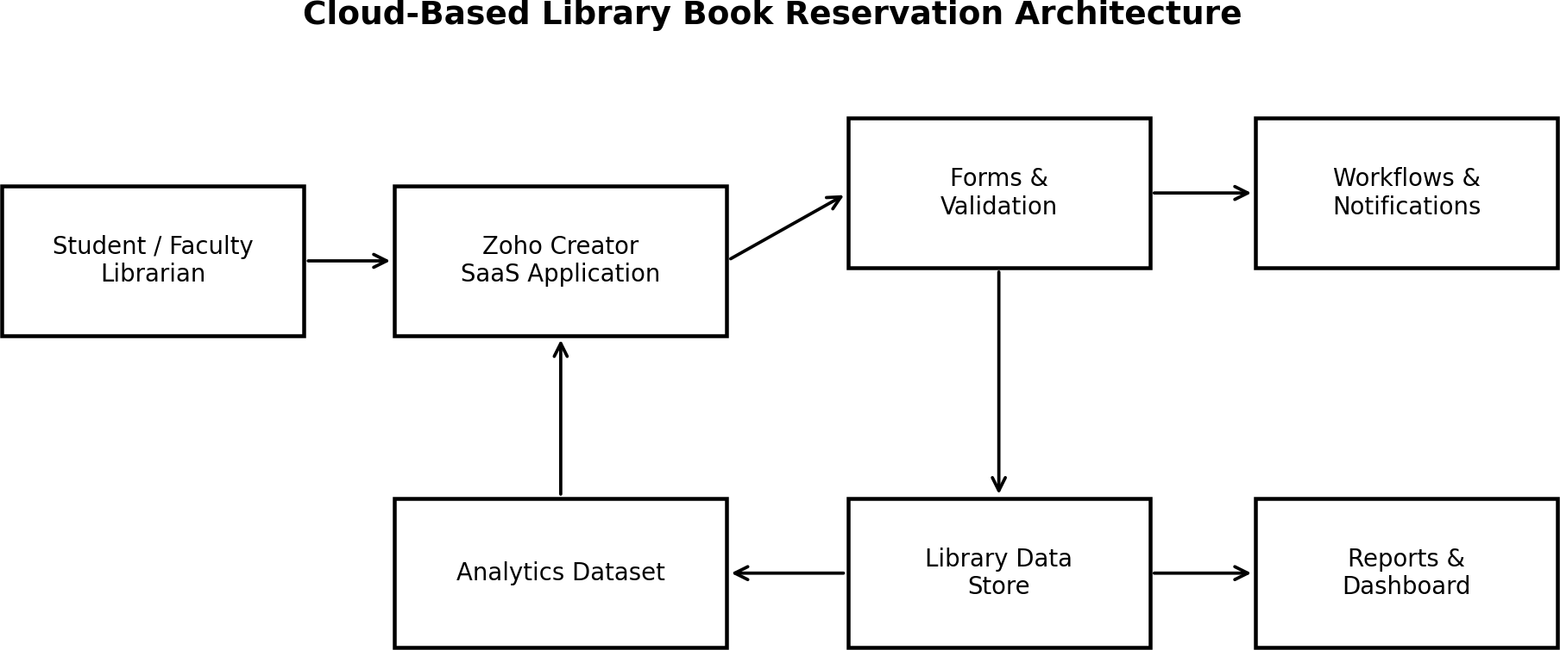

Figure 1. Conceptual cloud architecture for the library application.
At the user side, students, faculty and librarians access the application through a web browser. The Zoho Creator SaaS environment provides the application layer, while forms and validation capture data. The stored library data feeds reports and dashboards. A separate analytics dataset can be exported or prepared for MapReduce processing.
The virtualization concept is relevant because SaaS applications ultimately depend on compute, storage and networking resources. Users do not need direct visibility into those physical resources. This separation is a key advantage of cloud services: the application can be consumed without the user managing the underlying data-center hardware.

SYSTEM DESIGN / PROPOSED SOLUTION
The proposed system follows a layered design. The presentation/access layer is the Zoho Creator web interface. The application layer contains forms, validations and workflow rules. The data layer stores book, member and transaction information. The reporting layer provides operational views. The analytics layer uses a prepared transaction dataset for frequency aggregation.

Layer | Main components | Purpose
Access | Browser / user role | Reach the cloud application
Application | Forms, validation, workflow | Capture and control operations
Data | Book, Member, Reservation, Issue/Return | Maintain structured records
Reporting | Reports and dashboard | Support monitoring and decisions
Analytics | Dataset + mapper + reducer | Measure reservation demand

Primary roles
- Student/Faculty: search books, view availability, reserve/cancel and check status.
- Librarian: maintain books, manage copies, approve reservations, issue/return books, manage due dates/fines and generate reports.
- System/administrator role: configure access, forms, workflows and reporting components as permitted by the platform.
The design is intentionally modular so that the same transaction information can support both day-to-day library operations and later analytics. A reservation is not only an operational event; it is also a data point that contributes to demand measurement.

LOGICAL DATA MODEL
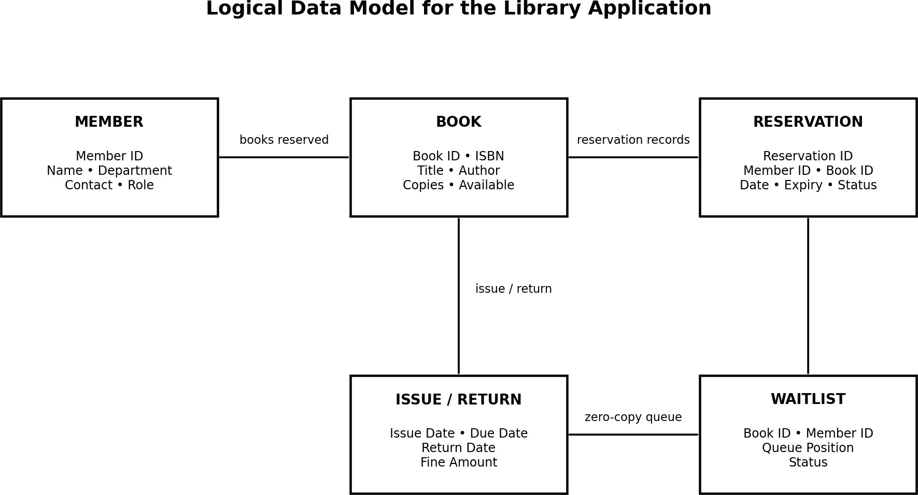

Figure 2. Logical relationship view of the library data model.
The central entities are Member, Book and Reservation. Issue/Return information extends a reservation into the circulation lifecycle, while a Waiting List entity can represent demand when a book has no immediately available copy.
The Book entity is identified by Book ID and stores bibliographic and inventory information. Member stores the identity and contact attributes needed to associate a user with a transaction. Reservation connects a member to a book and records reservation date, expiry and status. Issue/Return records capture circulation dates and fine information. Waiting List preserves the queue context for unavailable books.
In a normalized relational design, identifiers such as Member ID and Book ID provide stable references between records. In Zoho Creator, these relationships can be represented through suitable field types and lookups/relationships. Validation should prevent missing mandatory identifiers and should keep inventory values logically consistent.

BOOK, MEMBER AND RESERVATION FIELD SPECIFICATION

Entity | Field | Purpose / validation idea
Book | Book ID | Unique identifier; mandatory
Book | ISBN | Bibliographic identifier where applicable
Book | Title | Searchable title; mandatory
Book | Author | Author name
Book | Publisher | Publication information
Book | Edition | Edition number/text
Book | Category | Classification for search/analytics
Book | Rack Number | Physical location
Book | Number of Copies | Total inventory; non-negative
Book | Available Copies | Cannot exceed total copies
Member | Member ID | Unique user identifier
Member | Member Name | Required display name
Member | Department | Academic/organizational department
Member | Contact | Contact information
Reservation | Reservation Date | Date request is created
Reservation | Expiry Date | End of reservation validity
Circulation | Issue/Due/Return Date | Track book lifecycle
Circulation | Fine Amount | Non-negative monetary value
Status | Status | Available/Reserved/Issued/Returned/Waiting-list as applicable
The assignment question also identifies ISBN, book title, author, publisher, edition, category, rack number, copies, member details, reservation dates, issue/return dates, fine amount and status as required information. These fields form the basis of the application and analytics preparation.

ZOHO CREATOR IMPLEMENTATION PROCEDURE
The implementation procedure follows the sequence suggested by the supplied report-subtopic structure and the assignment requirements.
- Create or access the Zoho Creator environment and create a new application for the library.
- Create the Book form and add bibliographic, inventory and status fields.
- Create member/user-related fields or a Member form for reservation identification.
- Create reservation and circulation information with dates, status and fine fields.
- Configure required fields and basic validation rules.
- Create reports for library records, available books and reservation-related views.
- Configure workflow ideas such as availability checks, reservation status updates and waiting-list handling.
- Create a dashboard/navigation structure that provides access to forms and reports.
- Enter sample records and verify that reports display the expected data.
- Capture screenshots as implementation evidence and maintain the analytics dataset separately for MapReduce processing.

Environment / tools

Tool / environment | Use in the assignment
Zoho Creator | SaaS application, forms, reports and cloud access
Web browser | Application access and testing
Python 3 | Sample dataset generation and MapReduce-style scripts
CSV | Portable transaction dataset format
PDF/DOCX reporting tools | Assignment documentation and evidence packaging

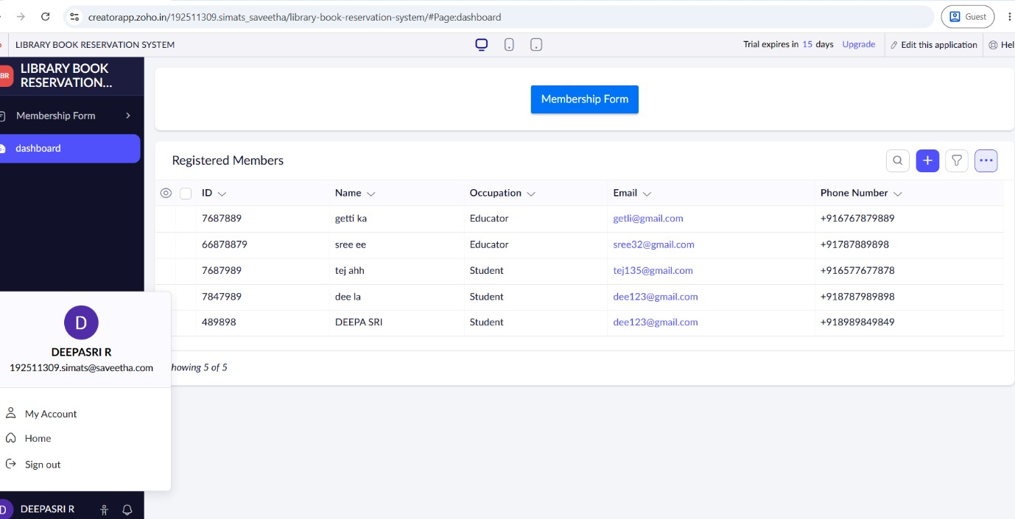

Library Dashboard

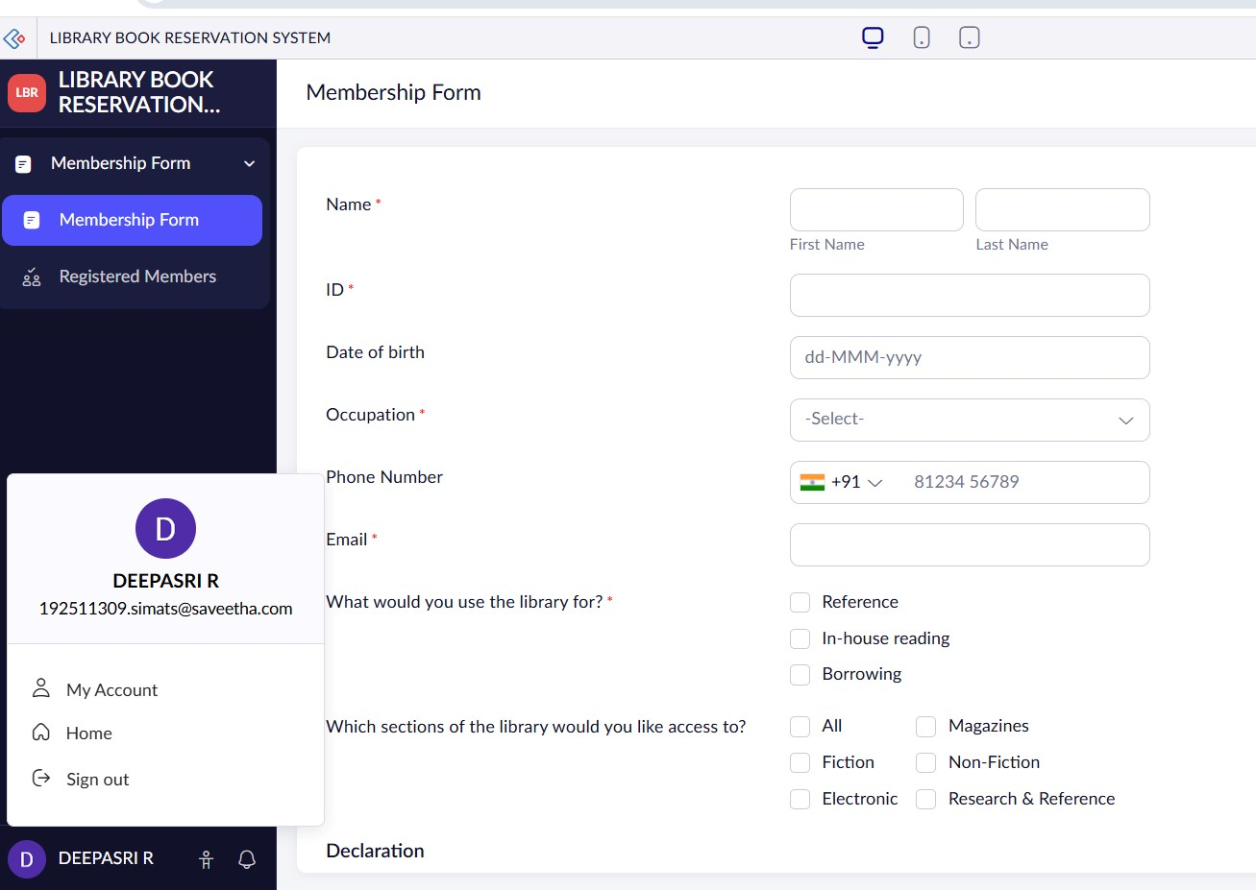

Book Form

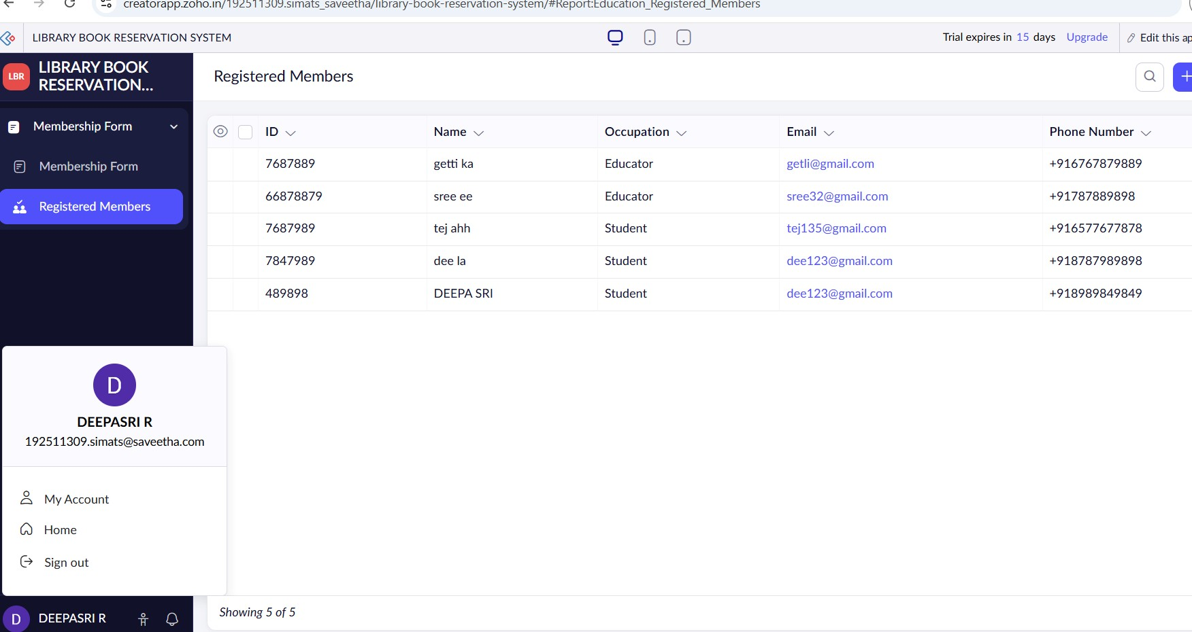

Book Form Report



Book Form Report

FORMS CREATED AND DATA ENTRY
Forms are the main data-capture mechanism in the proposed Zoho Creator application. The Book Form is the core form demonstrated in the supplied evidence. The assignment specification additionally requires member and reservation information, so the complete design extends the form structure to cover those entities.
Form | Main fields | Primary user
Book Form | Book ID, ISBN, title, author, publisher, edition, category, rack, copie | sL,ibarvaarilanbility
Member Form | Member ID, name, department, contact, role | Librarian/Admin
Reservation Form | Reservation ID, Member ID, Book ID, reservation/expiry date, status | Student/Faculty/Libraria
Issue/Return | Reservation/Book reference, issue date, due date, return date, fine | Librarian
Waiting List | Book, member, request date, queue position, status | System/Librarian

n

Data-entry principles
- Use stable IDs rather than relying only on names.
- Keep inventory values numeric and non-negative.
- Use controlled status choices instead of free-form text where possible.
- Keep reservation dates logically ordered.
- Associate every reservation with a valid member and book.
- Record issue, due and return dates separately so circulation history is preserved.

VALIDATION AND DATA QUALITY RULES
Validation reduces incorrect records before they enter the reporting and analytics pipeline. Because the assignment rubric specifically evaluates forms, relationships and effective validation, the following rules are recommended for the completed system.

Rule | Example condition | Reason
Unique Book ID | No duplicate identifier | Prevents ambiguous book references
Required title | Title is not blank | Supports search and reporting
Copy bounds | 0 ≤ Available ≤ Total Copies | Protects inventory consistency
Reservation dates | Expiry ≥ Reservation Date | Prevents invalid period
Member reference | Member ID exists | Prevents orphan reservation
Book reference | Book ID exists | Links reservation to inventory
Fine amount | Fine ≥ 0 | Prevents invalid monetary value
Status control | Value from allowed status set | Improves data consistency
Contact format | Valid expected contact pattern | Improves member data quality
Validation is also important for analytics. If one transaction records a book as “B01”, another as “Book-01” and another uses a blank ID, the mapper cannot reliably group the same book. Consistent identifiers therefore improve both the operational system and the MapReduce result.
Privacy consideration: Member names and contact details are sensitive operational data. The analytics dataset should use only the fields needed for analysis, and access to member-level information should be restricted according to the application's role model.

RESERVATION WORKFLOW AND AUTOMATION
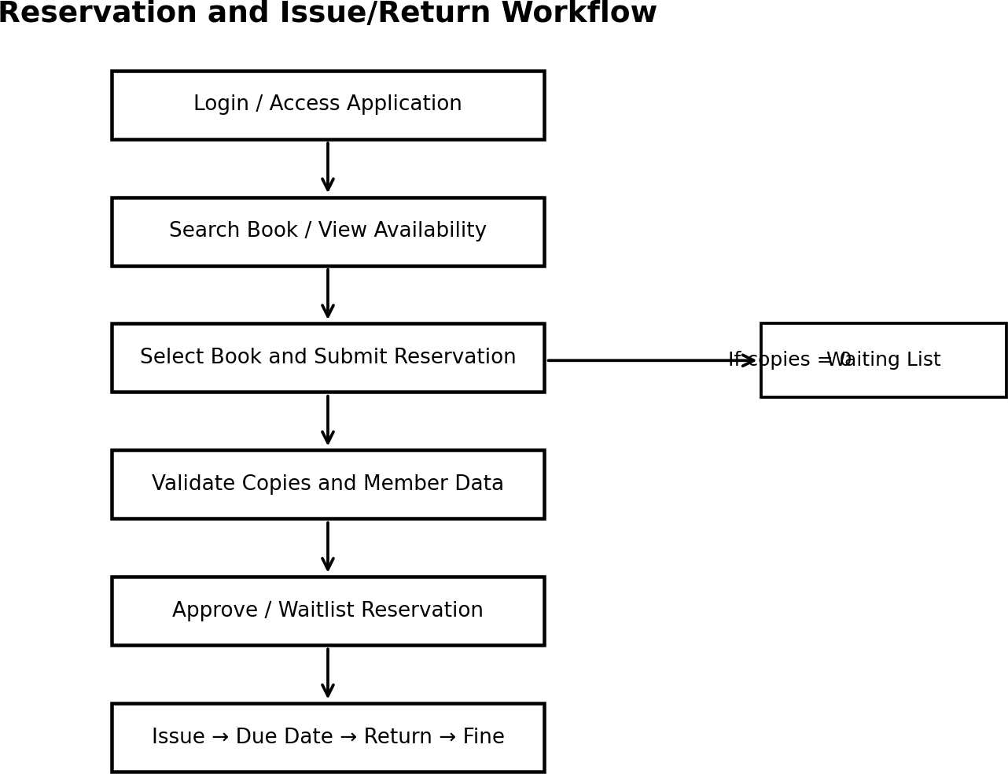

Figure 5. Proposed reservation and circulation workflow.
The workflow begins with authenticated access and a book search. The user selects a book and submits a reservation request. The application validates the member and book references and checks availability. When a copy is available, the reservation can proceed to approval/issue; when no copy is available, the request is represented through a waiting-list path.
Availability should be updated whenever a book is issued or returned. A reservation should not be considered complete merely because a form was submitted; its status should indicate where it is in the lifecycle. This makes reports more useful and reduces confusion between requested, approved, issued and returned states.
Automation opportunities: notification on reservation approval, notification before expiry/due date, automatic reduction/increase of available-copy count, waiting-list promotion after return, and fine calculation based on overdue duration. These are design-level workflow rules; the screenshots supplied in this submission primarily evidence forms and reports.

SEARCH, REPORTS AND DASHBOARD
Reporting converts stored records into information that librarians can use. The supplied evidence demonstrates report views and sorting. The complete design extends this into a report set aligned with the assignment.

Report / view | Purpose
Library Report | General book catalogue with bibliographic and copy details
Book Form Report | Book records displayed in a sortable report
Available Book | Show books currently available for reservation
Reservation Report | Track reservations by status and date
Waiting List Report | Monitor demand for unavailable books
Issue/Return Report | Track circulation and overdue/fine information
Category Demand Report | Compare reservation frequency by category
Dashboard | Provide a summarized operational view
The dashboard can use summary cards such as total books, available copies, active reservations, waiting-list requests and overdue items. Charts can show category demand or reservations over time. These visual summaries support faster decisions than inspecting every individual record.
The screenshots show that report sorting is already part of the demonstrated application state. Sorting by Book id provides a simple example of report interaction and validates that records can be organized for inspection.

BIG DATA PROBLEM ANALYSIS
Library transaction data becomes increasingly useful as the number of reservations, issues, returns and searches grows. The assignment specifically asks the team to identify big-data issues including volume, velocity, variety, data quality, privacy and scalability.

Big-data dimensi | oLnibrary example | System implication
Volume | Many years of reservations and circulation | Efficient storage and aggregation
Velocity | New transactions arrive continuously | Frequent or near-real-time updates
Variety | Forms, CSV exports, reports, logs and text | Schema/format normalization
Veracity | Duplicate IDs, missing dates, inconsistent categories | Validation and cleaning
Privacy | Member contact and transaction history | Role-based access and minimization
Scalability | Increasing books, members and transactions | Partitionable analytics and cloud resources
A small classroom dataset does not itself qualify as industrial-scale big data. Its value is that it models the structure of a continuously growing transaction stream and lets the team demonstrate the analytical method. The MapReduce design can then be conceptually scaled by distributing mapper tasks over partitions of a much larger dataset.
The most important quality principle is that analytics should use consistent keys. Book ID is preferable to title text because titles can vary in spelling, punctuation or edition. Category values should also be standardized before aggregation.

SAMPLE LIBRARY-TRANSACTION DATASET
A sample dataset was prepared to support the required analytics component. It contains 100 transaction records with fields for transaction ID, member ID, book ID, title, category, transaction date and status. The dataset is synthetic and is intended for demonstration rather than representing actual library users.

Field | Example | Analytics use
Transaction_ID | T001 | Unique transaction reference
Member_ID | M101 | Optional grouping/audit reference
Book_ID | B001 | Primary aggregation key
Book_Title | Introduction to Cloud Computing | Readable result label
Category | Cloud Computing | Category-level aggregation
Transaction_Date | 2026-08-14 | Time-based analysis
Status | Reserved | Filter valid reservation events
For the generated 100-row demonstration dataset, reservation frequency was calculated by counting each Book_ID occurrence. The most frequent book in this sample is B001, “Introduction to Cloud Computing”, with 13 reservations. This result is a property of the prepared sample dataset, not a claim about the actual library's most demanded book.

Dataset preparation steps
- Define a consistent schema and identifier format.
- Generate or collect transaction rows.
- Check required fields and date formats.
- Remove or prevent duplicate transaction IDs.
- Select the analytical event to count – reservation.
- Feed Book_ID and a value of 1 into the mapper.

MAPREDUCE APPLICATION DESIGN
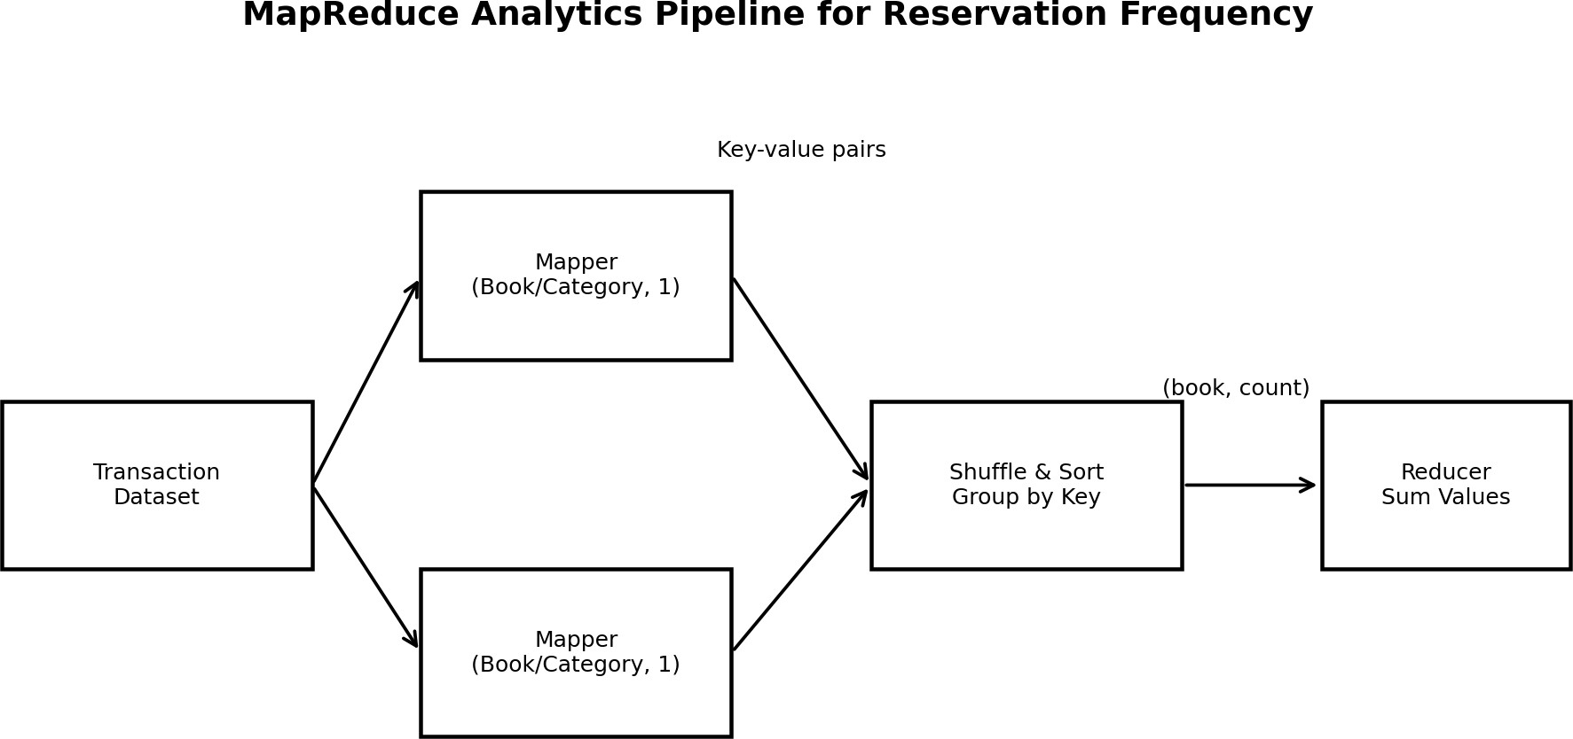

Figure 6. MapReduce pipeline for reservation-frequency analysis.
The MapReduce problem is a classic counting task. Each reservation record is converted into a key-value pair in which the key is the Book_ID and the value is 1. The shuffle-and-sort stage groups identical keys. The reducer then sums the values for each key.
Mapper logic: Read each transaction and emit (Book_ID, 1). If the same book occurs in 13 transactions, the mapper produces thirteen pairs with the same key.
Reducer logic: For each grouped Book_ID, initialize a counter and add each value. The final pair is (Book_ID, total reservations). The same design can be changed to use Category as the key to calculate category-level demand.
The advantage of the pattern is that mapping can be performed independently over partitions of a large transaction file, while reducers aggregate grouped keys. This directly connects the classroom implementation to the distributed-processing concept expected under CO5.

MAPREDUCE SOURCE CODE AND ANALYTICS OUTPUT
The following compact Python scripts implement the mapper and reducer logic used for the sample CSV dataset. They follow the key-value idea of MapReduce and can also be adapted to Hadoop Streaming by using standard input/output.

mapper.py
#!/usr/bin/env python3 import sys, csv

reader = csv.DictReader(sys.stdin) for row in reader:
print(f"{row['Book_ID']}\t1")

reducer.py
#!/usr/bin/env python3 import sys

current_key = None total = 0
for line in sys.stdin:
key, value = line.strip().split("\t") value = int(value)
if current_key == key: total += value
else:
if current_key is not None: print(f"{current_key}\t{total}")
current_key = key total = value

if current_key is not None: print(f"{current_key}\t{total}")
For local testing, the mapper output can be sorted by key and piped into the reducer. The generated result file contains Book_ID, Book_Title and Reservation_Frequency. In the supplied sample, B001 is the highest-frequency book with 13 reservations.
Source files delivered with this report package: library_transactions.csv, mapper.py, reducer.py and mapreduce_book_frequency.csv.

TEST CASES AND VALIDATION
Testing checks whether the implemented forms/reports and analytical logic behave as expected. The application screenshots provide visual evidence for the report views, while the test matrix below defines the functional scenarios that should be verified.

TC | Scenario | Expected result | Evidence/status
T01 | Open library dashboard | Navigation and search controls visible | Screenshot evidence
T02 | Open Book Form | Book fields available for entry | Screenshot evidence in ss.pdf
T03 | View Library Report | Book records displayed with columns | Pass – Figure 3
T04 | Sort Book id | Records reorder by selected sort | Pass – Figures 3/4
T05 | View Available Book | Only available records shown | Evidence in ss.pdf
T06 | Reserve available book | Reservation created and status updated | Design/test case
T07 | Reserve unavailable book | Waiting-list path used | Design/test case
T08 | Return book | Return date recorded; availability updated | Design/test case
T09 | Mapper count | One key-value pair per reservation | Verified on dataset
T10 | Reducer count | Frequency sum per Book_ID | Verified; B001=13
Because the supplied screenshots do not show every workflow state, reservation approval, waiting-list promotion and fine calculation are documented as testable requirements rather than falsely represented as screenshot-proven results. This distinction preserves the integrity of the evidence.

RESULTS AND DISCUSSION
The demonstrated Zoho Creator application successfully presents the core library data through forms and reports. The evidence set shows a library dashboard, a Book Form, a Book Form Report, a Library Report and an Available Book report. The two newly supplied screenshots strengthen the report evidence by showing two report configurations with different Book ID sorting orders.
Result area | Observation
Cloud access | Application is accessed through a web interface in Zoho Creator.
Book records | Book ID, title, author, publication, year, edition and copies are visible in reports
Sorting | Book ID sorting is demonstrated in both report screenshots.
Availability | An Available Book view is included in the screenshot evidence PDF.
Analytics | 100-row synthetic transaction dataset prepared.
MapReduce | Book-frequency aggregation produces B001 as top sample book with 13 reserv

.

ations.

The main analytical insight is that reservation frequency can be transformed into a simple demand indicator. A librarian could use this measure to compare books or categories, identify consistently high-demand resources and consider whether additional copies are justified. In a larger system, the same pipeline could be extended to monthly trends, department-level demand or overdue-risk analysis.
The result should be interpreted within the limits of the sample. The generated dataset is synthetic and therefore demonstrates the algorithm rather than measuring actual student demand.

ADVANTAGES, LIMITATIONS, SDG RELEVANCE AND CONCLUSION

Advantages
- Cloud accessibility through a SaaS application.
- Centralized library records and structured reporting.
- Reduced manual consolidation of book information.
- Clear separation between operational records and analytics processing.
- MapReduce aggregation can scale conceptually to larger transaction datasets.

Limitations
- The supplied application evidence is a demonstration dataset rather than production library data.
- Not every advanced workflow state is visible in the screenshots.
- The sample analytics dataset is synthetic and relatively small.
- Production deployment would require stronger authentication, backup, audit and privacy controls.
- Fine calculation, notification and waiting-list automation require further end-to-end verification.

SDG relevance
The assignment maps the project to SDG 4 (Quality Education), SDG 9 (Industry, Innovation and Infrastructure) and SDG 12 (Responsible Consumption and Production). A library reservation system supports educational access to learning resources, demonstrates digital infrastructure and can improve the utilization of existing books by making availability and demand more visible.
Conclusion: The project demonstrates a practical SaaS-based library information system and connects its transaction data to a MapReduce analytics task. It provides a foundation for extending the application with richer workflows, dashboards and scalable analytics.

CO MAPPING AND INDIVIDUAL REFLECTION – DEEPAK R (192511008)

CO | Evidence in this assignment
CO1 | SaaS explanation, Zoho Creator forms, requirements and validation concepts.
CO2 | Virtualization/cloud infrastructure architecture and relation to SaaS hosting.
CO3 | Cloud access, reports, workflows, collaboration and application evidence.
CO4 | Volume, velocity, variety, veracity, privacy and scalability analysis; dataset preparation.
CO5 | Mapper/reducer design, source code and reservation-frequency result.

Individual reflection – R. Deepasri (192511309)
My main contribution to the assignment was working with the Zoho Creator application and organizing the implementation evidence and report structure. I learned that a cloud application is more than a set of forms: the data model, validation rules, reports and workflow states must work together so that a user action produces a meaningful and traceable record.
A major learning point was understanding SaaS in practical terms. Instead of concentrating on server installation, the application is configured and accessed through the cloud platform. I also learned how the same operational records can become an analytics dataset. Choosing Book_ID as the MapReduce key made the reservation-count problem simple and scalable.
The most important challenge was keeping the report aligned with the assignment rubric while distinguishing actual screenshot evidence from features that are part of the required design but not visible in the supplied screenshots. This improved my approach to technical documentation because I had to avoid claiming that an unseen workflow had been executed.
The project strengthened my understanding of CO1–CO5 by connecting cloud service models, infrastructure concepts, cloud collaboration, big-data characteristics and MapReduce in one domain. The SDG connection also helped me see how better access to library resources can support education and responsible use of shared learning materials.

INDIVIDUAL REFLECTION –Parinitha (192525064) AND REFERENCES

Individual reflection – Parinitha (192511309)
My contribution focused on the data-model perspective, testing scenarios, workflow analysis and supporting the preparation of the transaction dataset. I learned that a reservation system requires more than book information: the relationship between a member, a book and a reservation must be maintained throughout issue and return activities.
Preparing the analytics dataset helped me understand the importance of clean identifiers and consistent fields. If Book_ID values are inconsistent, a frequency calculation can split one logical book into multiple keys. The mapper/reducer exercise showed how a simple counting problem can be expressed as distributed key-value processing.
The testing matrix also taught me to separate expected behaviour from evidence. A test case can be specified even when a screenshot does not prove the complete workflow. This is useful in software engineering because claims about implementation should be supported by reproducible evidence.
Overall, the assignment improved my understanding of cloud applications, data quality, reporting and big-data processing. The project relates to SDG 4 through improved access to educational resources and to SDG 9 through the use of digital cloud infrastructure.

References
- P. Mell and T. Grance, The NIST Definition of Cloud Computing, NIST Special Publication 800-145, National Institute of Standards and Technology, 2011. Available: https://doi.org/10.6028/NIST.SP.800-145. Accessed Sep. 2, 2026.
- Zoho Corporation, Understand Application – Zoho Creator Help. Available: https://help.zoho.com/portal/en/kb/creator/ developer-guide/creating-applications/understand-applications/articles/understand-application. Accessed Sep. 2, 2026.
- Zoho Corporation, Creating and Managing Form Workflows – Zoho Creator Help. Available: https://help.zoho.com/port al/en/kb/creator/developer-guide/workflows/create-and-manage-form-workflows/articles/create-new-form-workflow. Accessed Sep. 2, 2026.
- Zoho Corporation, Zoho Creator: Best Practices to Build Better Apps. Available: https://help.zoho.com/portal/en/kb/cre ator/developer-guide/getting-started/articles/zoho-creator-best-practices-to-build-better-apps. Accessed Sep. 2, 2026.
- J. Dean and S. Ghemawat, “MapReduce: Simplified Data Processing on Large Clusters,” Proceedings of OSDI'04, pp. 137–150, 2004. Available: https://research.google/pubs/mapreduce-simplified-data-processing-on-large-clusters/.
Accessed Sep. 2, 2026.
- Apache Software Foundation, Apache Hadoop MapReduce Tutorial. Available: https://hadoop.apache.org/docs/current1/mapred_tutorial.html. Accessed Sep. 2, 2026.
- Apache Software Foundation, Apache Hadoop Mapper API Documentation. Available: https://hadoop.apache.org/docs/current/api/org/apache/hadoop/mapreduce/Mapper.html. Accessed Sep. 2, 2026.
- United Nations Department of Economic and Social Affairs, Sustainable Development Goal 4: Quality Education. Available: https://sdgs.un.org/goals/goal4. Accessed Sep. 2, 2026.
- United Nations Department of Economic and Social Affairs, Sustainable Development Goal 9: Industry, Innovation and Infrastructure. Available: https://sdgs.un.org/goals/goal9. Accessed Sep. 2, 2026.
- United Nations Department of Economic and Social Affairs, Sustainable Development Goal 12: Responsible Consumption and Production. Available: https://sdgs.un.org/goals/goal12. Accessed Sep. 2, 2026.
- Department of Computer Science and Engineering, SIMATS Engineering, CSA15 – Cloud Computing and Big Data Analytics: Library Book Reservation System using Zoho Creator (SaaS) with Big Data Analytics, course assignment document.
- Department of Computer Science and Engineering, SIMATS Engineering, Instructions for Common Assignment, Evaluation and Submission, course instruction document.
Submission package: 30-page report PDF, screenshot evidence PDF, sample transaction CSV, mapper.py, reducer.py and MapReduce result CSV.

